**WHASP Service Review – Repairs & Maintenance**

**A report of a scrutiny review into the process of reporting a repair and the maintenance service**

**Introduction**

Warrington Housing Association Scrutiny Panel (WHASP) agreed to complete two service area reviews this financial year. This is to allow the panel to scrutinise and review the processes of the chosen service areas and provide recommendations to the Audit and Risk Committee (ARC) and Senior Management Team (SMT) where improvements can be made to enhance and develop the customer journey.

We requested to focus our time on the repairs reporting process and maintenance service as a whole for this review. This report will outline the overall scope of the review, the processes followed, how we carried out the review and the data collected.

WHASP has carried out several reviews of Warrington Housing Association ( WHA) services to date, these include voids, anti-social behaviour and most recently allocations.

These reviews have produced several positive and constructive recommendations to ARC and WHA for improving services, many of which have been accepted and implemented.

**Scope of review**

The Scrutiny Group initially met in June 2023 to determine the scope and develop a plan to carry out the review.

WHASP agreed the scope of the review would:

* To scrutinise the repairs process and the customer’s journey in reporting a repair
* Investigate what customers know about the planned works programme
* Review the level of satisfaction with work carried out by contractors
* Review customers satisfaction with the contractors attending to complete work
* Scrutinise responsibilities of the customer and WHA in relation to repairs

WHASP will

* Prepare a report with any findings and recommendations, this will be presented to SMT and ARC
* Monitor the implementation of any recommendations as a result of the review.

WHASP decided to

* Create a survey to enable the scrutiny panel to obtain the opinions of customers who have reported repairs and had contractors attend their property to complete repairs
* Hold several sessions to make contact with a sample of customers to complete the survey
* Speak to the Customer Support Team (CST) who process the majority of repairs requests
* Speak with the Head of Assets and Property Services Officers
* Review the Repairs Policy
* Review information held on WHA website

**How the review was carried out**

To gain some knowledge of the maintenance service and repairs process, we were provided with access to the following,

* Repairs Policy
* Rechargeable repairs policy and procedure
* Procurement Policy
* WHA Newsletters
* WHA website
* WHA colleagues
* WHA sign up pack

We met with the Customer Support Team to gain an understanding of the customer’s journey of reporting a repair. We were shown the various methods that repair requests came in, including by phone, email and via the website.

CST explained the process they followed when a customer reports a repair, advised of questions they ask to ascertain further details around the issue. They showed us how Home Master works in relation to loading a repair request, how they pick a suitable template for the repair depending on what it is and how the system allocates a specific contractor to the job. An area of interest of WHASP was around how CST or other colleagues were aware if a customer had any vulnerabilities. CST showed us that warnings are added to the account or person page of Home Master to indicate if there is a vulnerability and informs where the advisor can find further data on this, warnings can be set to show other information that is necessary for WHA colleagues or contractors to be aware of, such as ‘’.

WHASP also met with the Head of Assets and the Property Services Officers. This gave the panel chance to understand the repairs process from the maintenance side, what happens with pre-inpections when they are received by assets. The Head of Assets was very open about the pressures of compliance work, how important accessing properties for gas and electrics checks are and the process that is followed to achieve this. The Property Service Officers gave accounts of a typical day, including prioritising pre-inspections around damp and mould and completing stock conditioning surveys, they explained the importance of these surveys to help shape the future planned works programmes- programme of works to improve stock across WHA including bathroom and kitchen upgrades, new window programmes in areas. The Head of Assets was keen for WHASP to carry out questions with customers to provide feedback on contractors working for WHA.

The discussions with the WHA staff did give us all a lot of reassuring information in the way in which the Asset team manage and prioritise their work. Also, the demonstration from Customer Service Team of the Home master system really helped us seeing the process of how certain repairs have different priorities and how they match with the contractor that is best placed to carry out the repair.

To enable WHASP to gain an understanding of customer thoughts and experience of the repairs process, we chose a random sample of 132 customers off the Home Master system to contact and ask a series questions to determine how the customer experience is for them. This would be 10% of the overall stock of WHA properties. We split this sample across the following tenures-

* Shared ownership
* Market rent
* Affordable rent
* General needs
* Housing for older people
* Leasehold

**What ways were used to contact customers**

The Scrutiny Panel have used various ways of contacting customers in past reviews. In this instance we decided the use of telephone calls and email surveys would be the best contact method, so we arranged dates and to maximise responses we arranged different sessions to carry them out. Two sessions in the day during office hours and an emailed survey of customers we were unable to contact over the phone. Through these phone calls and emailed surveys, WHASP were able to obtain feedback from 43 out of 120 customers, equating to 32% of the sample.

We compiled a questionnaire which covered repairs, planned maintenance and information about contractors.

**Evidence and Data**

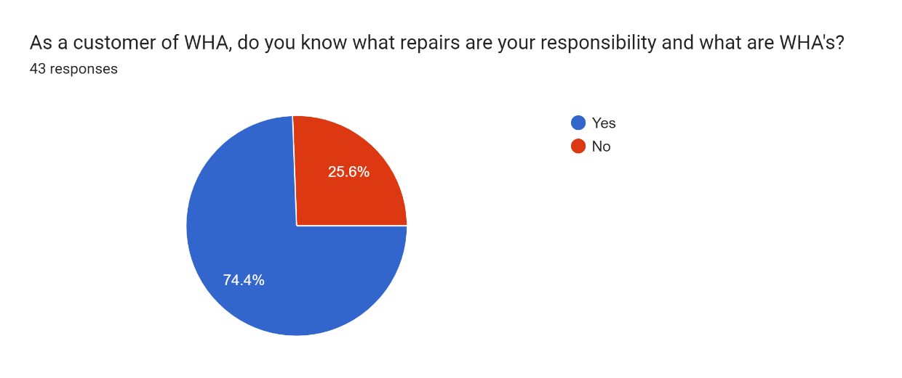

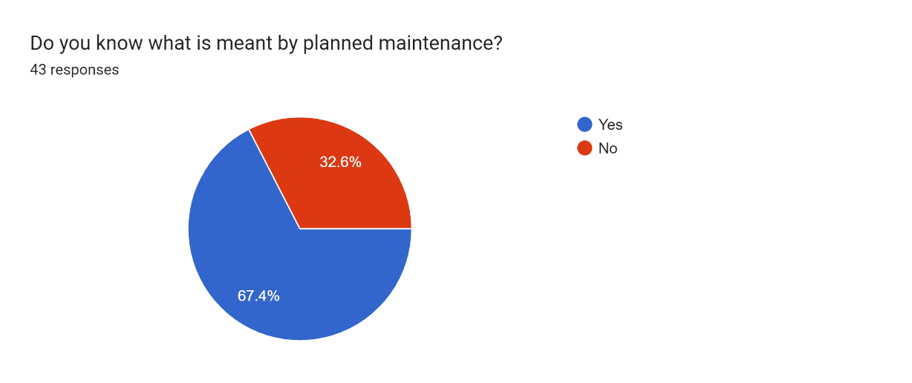

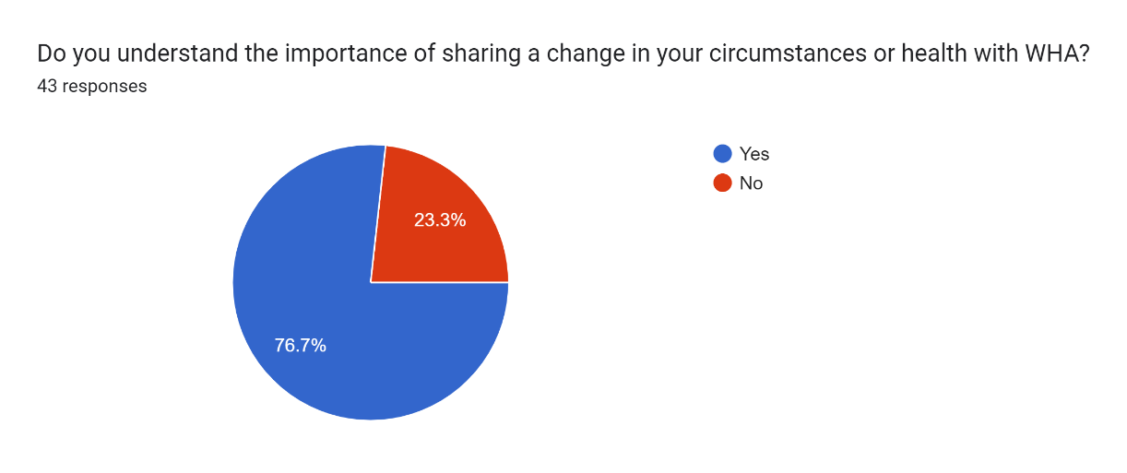

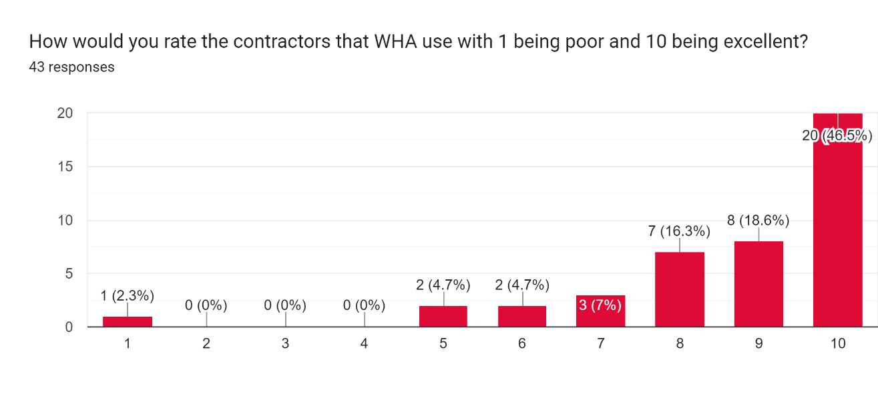

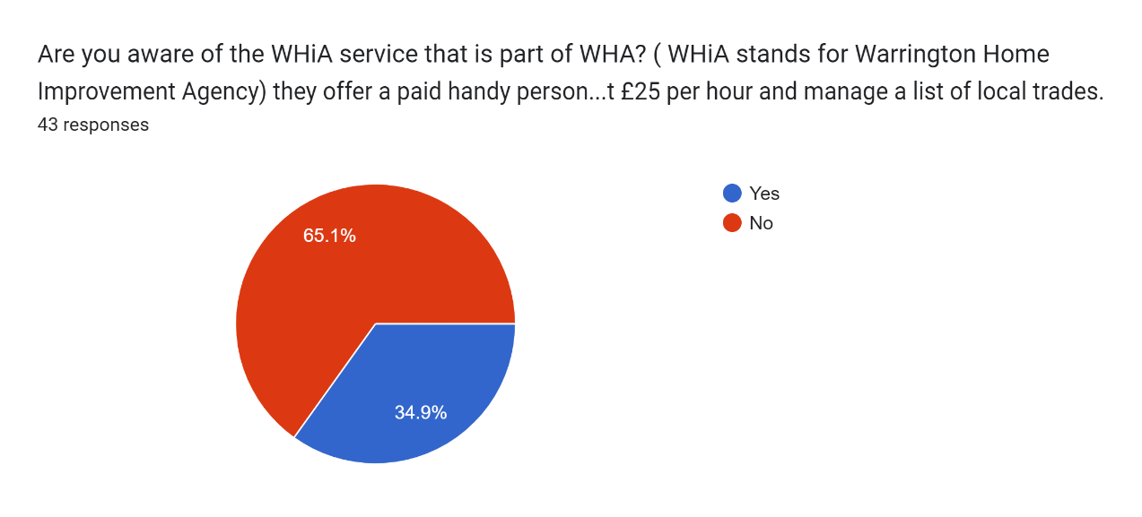

Feedback

WHASP are aware we did not contact a great proportion of the sample customers as the last review. We did not operate an evening session for phone calls this time, which we feel may have gained a larger response, especially from those who work. This will be factored into the next review.

We were extremely pleased that nearly 50% of the sample gave the contractor 10 out of 10. The customer that has provided 1 of out 10, did not give a clear reason for this score and this will be referred to the assets team to follow up further.

100% of the sample questioned knew how to report a repair, with 65% preferring to use the phone and 16% using the website. The other results shown above have helped to shape the recommendations that we are providing to WHA in order to improve the maintenance and repairs survey for the customer.

**Recommendations**

Upon analysing the data WHASP have suggested the following recommendations

|  |  |  |  |  |
| --- | --- | --- | --- | --- |
| **Reviewed by WHASP** | **Recommended** | **Date Reviewed by WHA** | **Accepted/Not Accepted implementation** | **When** |
| Ways to report repairs | WHASP recommend that WHA provide more communication to customers of alternative ways to report repairs; to try and encourage more self service without relying on calling into WHA. | 24/10/2023 | Accepted – Target to increase customers registered on the portal  Operation Blazer – Development of HM |  |
| Customer and WHA repair responsibility | WHASP were concerned at the percentage of the sample (25%) were unsure where responsibility for repairs lie.  WHASP recommend that Assets and Housing teams work on providing accurate information for new customers and cascading to current customers, so all customers know what their responsibilities are in line with their tenure type. | 24/10/2023 | Accepted – Review website  Online sign-up pack to be developed |  |
| Planned maintenance | WHASP received comments during their calls where customers do not know either what planned works are or how to find out when their property may be eligible for planned works.  WHASP recommend that the way in which WHA communicate about planned works is reviewed and made more accessible to customers. They also have reviewed to page on the website where it shows planned maintenance, but the information is not clear.  Recommendation that planned works are communicated to new customers upon tenancy sign up, so they have an awareness from the outset of the tenancy. | 24/10/2023 | Developed inline with the Planned Maintenance Module in HM |  |
| Updating changes in customer circumstances | The majority of the sample surveyed were aware of the importance of updated changes in circumstances.  WHASP recommend that this should be discussed at sign up and at any interaction with customers such as when they call to report a repair, come into the office, tenancy visits etc to keep the data of customers as up to date as possible. | 24/10/2023 | Accepted – Embed the use of HM  Develop suite of tenancy audits |  |
| Contractors and contracts | The majority of the feedback around the contractors was positive but there were a few negative responses.  WHASP recommend a further meeting with the Asset team to discuss this feedback so a contractor code of conduct could be introduced to ensure all contractors treat customers in a professional way and carryout work to the agreed standard.  WHASP also recommend that they would like to take part in the reviewing of contracts so that a customer voice can be recognised in the decision making. | 24/10/2023 | Accepted – Not in contract with any contractors except Ashley and McDonaugh  Consideration required around the performance of contractors given the historic use of sole traders |  |
| WHIA - Warrington Home Improvement Agency | Most of the customers surveyed were not aware of what the WHIA service is. With this being an integral service that WHA provides to customers and other residents of Warrington, WHASP was disappointed in this response.  WHASP recommend that WHIA’s profile needs to be raised and effective communication is done to ensure WHA customers and the wider community are aware of the service on offer. | 24/10/2023 | Accepted – need to consider how we communicate this |  |